Speed up charts for Assignment 5 OpenMP task:

1. Speedup chart for Reduce:

The Speedup increases with granularity. Compared to assignment 4 the speedup is much worse. We need to make sure to have high granularity to get higher speedup.

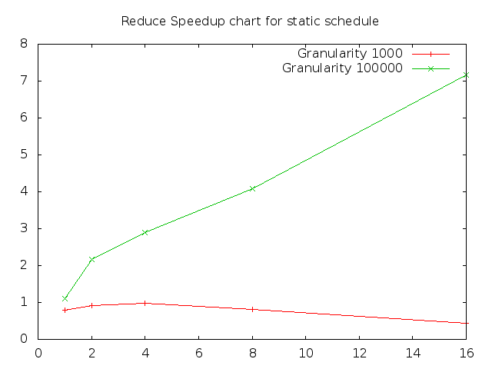

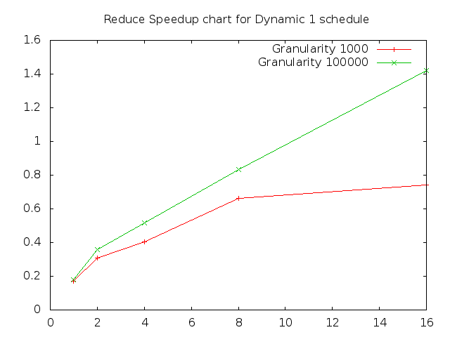

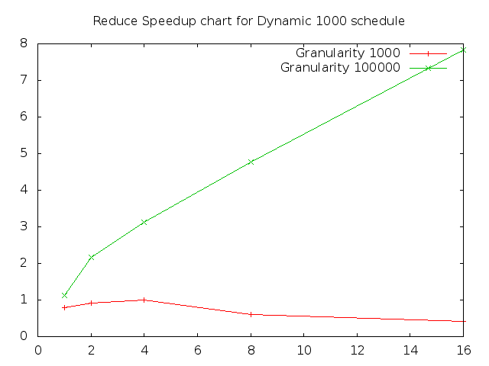

1. Speedup chart for Find First: Similar to reduce the speedup will be better for high granularity value or else it will be worse the speedup got in Assignment 4. For this assignment I have used granularity value of 100000.   
   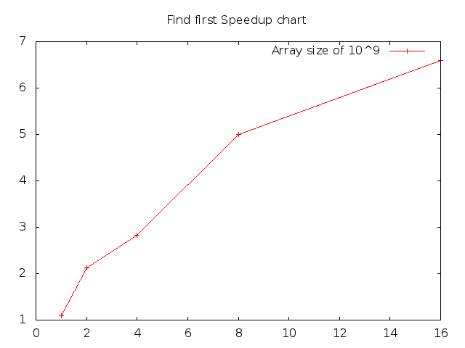
2. Speedup chart for Merge Sort: For constructing this graph I have used granularity value of 1. Compared to assignment 4 this speedup is much worse.

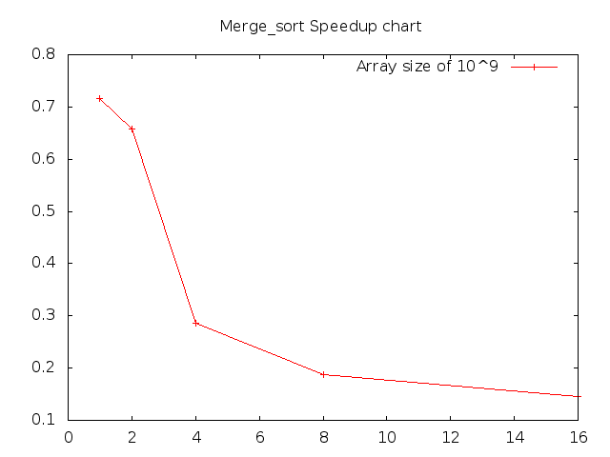

1. Speedup Chart for Strassen:

Below is speedup for 16 threads and varying operational intensity.

